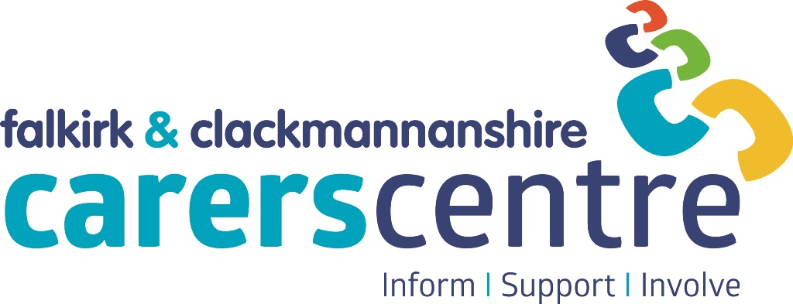

**Clackmannanshire**

Ludgate House

Mar Place

ALLOA

FK10 2AD

01259 226839

**Falkirk**

Bank Chambers

1a Bank Street

FALKIRK

FK1 1NB

01324 611510

**Application Pack**

**www**[**.centre@centralcarers.org**](mailto:.centre@centralcarers.org)

# **Principal Funders of Central Carers Association**

****https://clacksandstirlinghscp.org/wp-content/uploads/sites/10/2018/01/Retina.png



|  |
| --- |
|  |

**Managed by Central Carers Association (Falkirk & Clackmannan) | Company Limited by Guarantee | Company No SC184443 | Scottish Charity No SC023658**

Central Carers Association

Is the local voluntary organisation that supports carers in Falkirk district and Clackmannanshire and is the managing body of the Falkirk & Clackmannanshire Carers Centre. The organisation, which is a registered charity and limited company, is managed by a voluntary Board of Trustees who are elected from the membership of the organisation.

Mission Statement

To ensure that carers of all ages are recognised, valued, receive the information and support they need to allow them to care with confidence and in good health, and are empowered to have a life of their own outside caring.

Values

Central Carers Association aims to provide quality, confidential services that are sensitive to the needs and wishes of local carers, and provide opportunities to allow carers to participate in the development of local health and community care services to improve the quality of life for carers and those they care for.

Aims of the Association

* To identify carers and encourage mutual support
* To raise awareness of the needs of carers and establish carers support groups
* To co-ordinate views of carers within the Association's area by identifying and raising carers' concerns with policy makers and service providers
* To assist carers to liaise with all relevant agencies
* To promote services which help carers
* To collate and disseminate information relevant to carers within the Association's area
* To recognise and work with former carers within the Association's area as appropriate to their circumstances and experiences
* To promote the principle and practice of equal opportunities for all carers
* To promote good communication, collaborative working and partnerships between statutory, voluntary and community organisations which provide services to carers, in order to ensure better co-ordinated and more effective support to carers and respective service users

Privacy Notice

In accordance with the General Data Protection Regulation, Central Carers Association has developed a Privacy Notice for Job Applicants to inform prospective employees about the types of data we process, the reasons for processing this data, the lawful basis that permits us to process the data, how long we keep the data, and the rights of applicants regarding their data. This document can be viewed on our website: [www.centralcarers.org](http://www.centralcarers.org).

The Carers Centre

The Carers Centre is a growing and forward-thinking organisation with ambition to support an increasing number of children, young people and adults who provide unpaid care for a family member or friend due to disability, illness, addiction or frailty.

To achieve this, the Carers Centre provides information, support and involvement opportunities for carers, of all ages, across Falkirk district and Clackmannanshire.

Organisation Structure

The day to day management of the Carers Centre is delegated by the Trustees to the Carers Centre Manager. We currently have 29 members of staff who are based in various locations, including the Carers Centres in Falkirk and Alloa, Forth Valley Royal Hospital, Falkirk Community Hospital and Clackmannanshire Community Healthcare Centre.

Working for Central Carers Association

Staff benefits include:

* Competitive salary scales, with annual increments until top of scale is reached
* 8% contribution to Legal & General Workplace Pension Plan
* 20 days annual leave plus 14 days public holidays
* Flexibility around starting and finishing times and length of lunch breaks
* Regular supervision and support

Application Process

Details about the post are contained in the job description and person specification, which are included in the Application Pack.

To apply to work for Central Carers Association you need to fully complete our Application Form - CVs will not be accepted. **Shortlisting is dependent on applicants being able to demonstrate how their knowledge, skills and experience relate to the post applied for**.

If you are completing and returning the form electronically you will be required to sign your application form if you are appointed to the post.

The deadline for applications and interview dates are included in the advert for the post – please let us know as soon as possible if you would be unavailable on this date.

We will endeavour to let all applicants know the outcome of their application, however, we will not provide feedback on unsuccessful applications.

You should return your completed application, together with completed Equal Opportunities Monitoring and Criminal Convictions Declaration forms to:

[**recruitment@centralcarers.co.uk**](mailto:recruitment@centralcarers.co.uk)

**or**

**The Centre Manager**

**Falkirk & Clackmannanshire Carers Centre**

**1a Bank Street**

**FALKIRK**

**FK1 INB**

Thank you for your interest in working at the Carers Centre - we look forward to receiving your completed application.

**Central Carers Association**

**Job Description**

Job Title Carer Support Worker (Clackmannanshire)

Salary Scale £22417 (pro-rata for 30 hours)

Hours 30 hours

Responsible forThe provision of services that will seek to ensure that carers are identified and appropriately supported, both individually and through the development of carers’ groups, and provided with information and opportunities to get involved in the planning of services to support their needs and the needs of the people they care for

Main Duties

**Information and Support**

* Respond to face to face, telephone, email and postal enquiries from carers and professionals
* Provide information and emotional and practical support to individual carers, making home visits where required
* Provide information on grants and welfare benefits and assist carers to maximise their income
* Encourage and support carers to take up their right to an Adult Carer Support Plan
* Assist carers to develop a personalised Support Plan, Emergency Plan and Future Plan
* Identify and pursue funding opportunities for services for carers
* Encourage carers to join local carer groups and fora for mutual support and campaigning
* Organise and co-ordinate a range of regular support groups, one-off activities, and fixed term programmes for carers arranging the practical provision of care and transport, where appropriate, to enable carers to participate
* Assist and encourage carers and carer groups to define and prioritise their own needs
* Provide support, where appropriate, to carers when attending meetings with professionals
* Signpost and refer carers to other relevant sources of information and support

## **Awareness raising and networking**

* Raise the awareness and knowledge about the needs of carers by giving awareness raising talks and presentations
* Publicise and promote the services provided by the Carers Centre
* Encourage and support the early identification of carers and referral to the Carers Centre
* Promote the needs of carers at local planning groups/consultation events
* Establish and sustain supportive contacts with carers, carers groups and relevant organisations
* Liaise with local professionals and agencies providing services for carers
* Participate in the planning and organisation of conferences, seminars and events to raise awareness about carers issues

**Development**

* Develop and support new and existing carer groups in response to identified needs
* Explore and assist in the initiation of new projects to support carers in response to local needs
* Participate in the development and integration of emergency and future planning tools to support carers
* Develop information resources for carers
* Keep up to date with relevant new legislation and national and local policies and practice that affect carers
* Develop close working relationships with other member of staff in the Carers Centre and promote the provision of holistic family support

**Involvement**

* Encourage and support carers to be involved in the development of support groups, activity programmes and information resources
* Encourage and support carer involvement and participation as partners in the monitoring and development of services to support carers and the people they care for

**Recording and monitoring**

* Ensure efficient records are kept of carer activities
* Record and monitor all contact with carers and professionals
* Produce regular activity reports

Accountability

* Prepare regular work plans in agreement with the Centre Manager or another senior member of staff
* Maintain systems to record and monitor the activity of the service using the Carers Centres data management systems
* Participate in staff meetings
* Co-operate with the Board of Trustees in quality assurance exercises
* Work as part of an effective staff team to ensure the Centre functions efficiently and professionally
* Undertake any other duties relevant to the post, as reasonably required from time to time by the Centre Manager

Confidentiality

The post-holder is expected to adhere to high standards of confidentiality and data-protection at all times.

Personal Development

The post-holder is expected to participate in staff development and use all relevant learning opportunities to improve their personal skills.

Supervisory Relations

The post-holder will receive regular support and supervision from the Centre Manager or another senior member of staff.

Equal Opportunities

Central Carers Association (Falkirk & Clackmannan) is committed to being an equal opportunities employer. The post-holder will therefore be required to carry out their duties with due regard to Equal Opportunities legislation.

Quality Statement

The Association is committed to running an organisation with high standards of organisational and operational practice. To that end, the Centre operates a continuous programme addressing quality issues.

Location

* The post will be located in Ludgate House, Mar Place, Alloa, FK10 2AD.
* As the post-holder may be expected to travel throughout Clackmannanshire, and attend occasional staff meetings in Falkirk, the ability to drive, and access to a car, are requirements of this post.

**Person Specification**

|  |  |  |
| --- | --- | --- |
| **Skills and experience required for this post** | **Essential** | **Desirable** |
| Educated to degree level (or equivalent) or considerable previous experience in a related field | **✓** |  |
| An appreciation of, and sensitive approach towards, the needs and difficulties faced by carers | **✓** |  |
| Good telephone, listening, verbal and written skills and the ability to write reports | **✓** |  |
| Ability to use own initiative and organise own work in consultation with line manager | **✓** |  |
| Ability to develop and maintain effective working relationships | **✓** |  |
| Sound IT skills and experience in the use of all Microsoft Office applications | **✓** |  |
| Up to date knowledge of Welfare Benefits |  | **✓** |
| Personal experience of caring or of working with carers |  | **✓** |
| Experience of setting up and/or enabling community groups |  | **✓** |
| Experience of public speaking |  | **✓** |
| An understanding of current legislation and policy relating to carers |  | **✓** |
| Experience of multi-agency working |  | **✓** |